Staircase Detection System for the Visually Impaired People: A Review

Sheikh Nooruddin, Md. Milon Islam and Falguni Ahmed Sharna

*Department of Computer Science and Engineering*

*Khulna University of Engineering & Technology*

*Khulna-9203, Bangladesh*

*milonislam@cse.kuet.ac.bd*

**Abstract**— A paramount aspect of human beings has a sense of vision that naturally gifted by God, but some people are not capable to visually perceive things around the environment. Some of the major hindrances that are faced by the individuals in daily living are unable to detect obstacles, potholes, staircase, pedestrian, vehicles, etc. around the surroundings. With the increasing number of visually impaired people around the world, many works have been continued in this field to assist them. The main focus of this paper is to review the staircase detection systems that have been developed to aid the visually impaired people in navigation. In this paper, we represent a comparative review of the policies using different types of sensors and algorithms to extract the staircase through computer vision. We provide an overview on recently developed systems to help the researchers who want to contribute in this field in future.

Index Terms—Staircase Detection; Visually Impaired People; Sensors; Computer Vision.

# Introduction

According to the World Health Organization (WHO), about 253 million people are visually impaired. Among them, around 36 million people are blind and rest 217 million people have various vision impairment. Among the above 80%, people are 50 years aged or above [1].

As the world is progressing at a faster rate, new systems are being developed every day to make sure daily living are getting comfortable in every way possible. But for the people who have physical disabilities, they require more help than ordinary people. So, the technology has come up and trying to provide solutions so that they can live around the society just like normal people. Nowadays, the development of assistive devices for the visually impaired people has become a prominent research area. One of the most important and challenging tasks [2] is developing such systems with a user interface for the people with such physical disabilities while interfacing the sensors in the systems with real-world data.

In the last decade, many works [3]-[5] have been done in this field to help the visually impaired people in different directions. Some of the systems are in mobile devices [6], some for robot applications [7]-[9] and the others [10]-[14] for the visually impaired people using computer vision technology.

In this review, we provide a comparative study on research and systems so that we can bring up recent progress in this area to support people with visual impairment. The review incorporates the following issues: introducing the system, how the system works, which technology that have been used to develop the system, advantages and disadvantages of the system. A taxonomy of the reviewable staircase detection systems is also drawn on the basis of the use of technology like as sensor-based technology, vision-based technology, and hybrid approach. The taxonomy of the systems is shown in Figure 1.

The remaining part of the paper is organized as follows. Section II describes the staircase detection systems with three categories such as sensor-based system, vision-based system, and hybrid approach. The detailed discussion of the review is illustrated in Section III. Section IV concludes the review.

# Literature Review on Staircase Detection Systems

There are several recent techniques have been developed with the evolution of technology for detecting staircases to assist visually impaired people. The recent works in this field are described shortly as follows.

* 1. *Sensor-based Staircase Detection Systems*

The sensor-based staircase detection systems used sensors to collect data from the real world environment to detect the stairs. The systems used different types of sensors such as an ultrasonic sensor, gyroscope sensor, etc. The works associated with this area is outlined as follows.

J. Razavi and T. Shinta [15] developed a new approach for staircase detection to aid the visually impaired and blind people. The system can detect upward and downward stairs distinctly. It used an ultrasound sensor to determine whether it is upstairs or downstairs. The system is set to the user's head and used a reference distance that would correspond to flat ground. In terms of upstairs, the measured distance would be less than reference distance, and in case of downstairs, the measured distance would be more than the reference distance. A small may occur because of user's head moves up and down which is mitigated by using the gyroscope. The main components used in the system are an ultrasound sensor, a gyroscope, an Arduino Nano, and two buzzers. The prototype of the proposed system is shown in Figure 2. The system is lighter and more efficient which weight is roughly 140g. This system has a more straightforward interface, longer battery life which is around 18 days, low cost and low error rate and able to detect staircase even in the dark, foggy, rainy and snowy conditions. However, the system may generate false alarms when the user with taller heights.

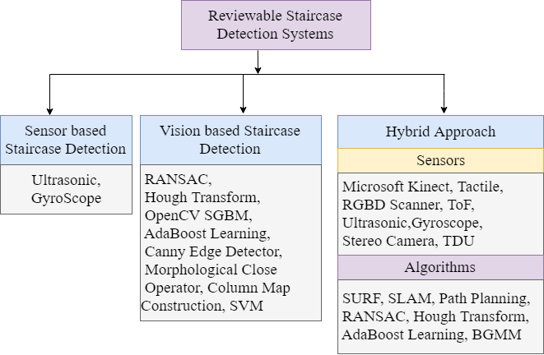

Figure 1: Taxonomy of the reviewable staircase detection systems for the visually impaired people

|  |  |
| --- | --- |
|  | C:\Users\CSE\Desktop\11.jpg |

Figure 2: Proposed prototype (a) downstairs with ultrasound (b) upstairs with ultrasound (c) staircase with ultrasound and gyroscope [15]

## Vision-based Staircase Detection Systems

Nowadays, computer vision [16]-[18] has become a prominent research area that is used to develop different types of walking assistants for the visually impaired people.The vision-based staircase detection systems used cameras (RGB-D, Stereo, Depth, etc.) to capture the real world environment and utilized appropriate algorithms to extract the staircase from the images. The works related to this area is outlined as follows.

Romić et al. [19] developed a camera-based assistance system to detect the staircases for the visually impaired people. The system captured the real scenario using the camera and convert the images into binary images using canny edge detection.

The canny edge detection procedure used two threshold values, the first threshold is used for initial segments of strong edges, and the next one is for linking of edges. The morphological closing operation used to eliminate unnecessary details from the binary images. Then the method proceeds with the structural analysis of the columns and rows. The proposed system is mainly focused on a resolution which is important for morphological operations and able to detect staircases for resolution 640X360 with the accuracy of 95.2% but works well with a slightly lower resolution like 320X180. However, the system only discussed the upward staircase, and for very high and low resolution it may not produce expected accuracy.

Khaliluzzaman et al. [20] proposed a stairways detection and distance estimation system for visually impaired people to improve a user's movement. The proposed system is divided into six primary steps. At first, Gabor filter is applied on stair image to extract stair edges properly. Then potential edges are extracted from the stair edges image. After the previous step is completed, the edge image only contains long horizontal edges. And then it finds three connected points by using canny edge image which includes both vertical and horizontal edges. Then it extracts increasing horizontal edge segments and validates by Three Connected Point (TCP). To estimate the distance from a camera to stair, two cameras are needed. The proposed system is efficient and appropriate for the visually impaired people. The system work under a variety of conditions and results are presented to demonstrate the efficiency and effectiveness of the framework. The system can also detect rail line and zebra-cross with staircases. However, the system is heavy-weighted, non-wearable and costly.

Furthermore, Romić et al. [21] developed a method of staircase detection to assist the visually impaired people to detect stairs in an unfamiliar environment. The preprocessing step in the system uses a combination of the canny edge detector and close morphological operator. Here, binary images with highlighted edges of different obstacles in the image including staircases are produced by the canny edge detector. To eliminate the negative effects, morphological closing operations are performed. To create criteria for the final detection the system uses a combination of specific vertical and horizontal analysis. The system processes the data very fast and detect staircase and accurately inform the user about the staircase. It can detect fairly within 2–4 meters and notify the user. However, the system cannot detect movement in the staircase and it cannot detect the staircase in the large range.

T. Schwarze and Z. Zhong [22] introduced a system for detection and tracking of upward-staircases to assist the visually impaired people and for the robots in multi-floor exploration scenarios. The system used the libViso library for computing the six Degree of Freedom (DoF) motion of a moving mono/stereo camera. Random sample consensus (RANSAC) algorithm produces an initial plane by repeatedly sampling planes through 3 random points. The disparity images are acquired with OpenCV semi-global matching (SGBM) at half resolution. It also applied a canny edge detector to remove edge crossing and connect points extracted by flood fill region growing. The components used in the system is the stereo camera. The proposed method is light-weight and works in a large range (up to 7-meter distance) to detect upward stairs. However, the system only detects the upward staircase. It cannot detect down staircases and pedestrians.

Shahrabadi et al. [23] developed a method for detection of indoor and outdoor stairs for aiding blind persons during navigation and for autonomous robots. The system used the Gaussian function for filtering the frames in order to mitigate the noise and then passes through a canny edge detector to detect a wider range of edges in frames. Then, Hough transform is applied for horizontal edges detection. Minimum and Maximum distance are, and if the distance between two edges is between the minimum and maximum distance, the edges are kept, and edges with smaller distance are discarded. The main components used in the system are a camera, processing device. The proposed method is able to detect both indoor and outdoor stairs with a different view of angles. It works fairer even if the frame is saturated either by sunshine or contained shadows or in dark place. However, the system provides poor (around 83%) accurate result for detection of staircases.

S. Wang and Y. Tian [24] demonstrated a stairs and pedestrian crosswalks detection system for visually impaired people to improve travel safeness. The system used a computer vision-based method to detect stair-cases and pedestrian crosswalks by using RGBD camera. The system used Hough transform to extract the concurrent parallel lines based on the RGB channels and then depth channel is used to recognize pedestrian crosswalks, upstairs and downstairs using Support Vector Machine (SVM). The proposed system is small and lightweight and user-friendly and provides exact information about up-down staircase and pedestrian. However, the system fails to detect in the dark and only works well in a closed distance.

* 1. *Hybrid Approach*

The hybrid system used both the sensors (ultrasonic sensors gyroscopes, Kinect sensor, tactile sensor, etc.) and cameras with processing devices. There were various types of algorithms used to extract stairs from images captured with the mainly RGB-D camera in a hybrid approach.

Ponnada et al. [25] proposed a manhole and staircase detection system for the visually impaired people that can help the individuals to avoid the manhole and staircase in the way of walking. The system used the ultrasonic sensor for the detection of manhole and staircase, and computer vision-based technique also used detect the hindrances. The SURF algorithm extracts the features from the real-time images, and Bivariate Gaussian Mixture Model (BGMM) is used to detect the staircase and manhole. The main components used the scheme are Arduino Kit, ultrasonic sensor, vibrator, HC-05 Bluetooth and camera. The proposed device is small and lightweight and will be effective for the blind and deaf people as the system will give notification to these about the current position they are in right now and give direction to them about the stairs. However, the system may faultier in the dark or in a place where there is so much sound. The system fails to categorize the moving obstacles in case of staircase detection.

Pham et al. [26] developed a real-time obstacle detection system in an indoor environment for the visually impaired people that can help individuals to avoid four types of obstacles. The obstacles are walls, doors, staircases and a residual class that covers loose obstacles on the floor. The system used the RGB-D camera to capture both RGB images and depth maps at a resolution of 640x480 pixels with 30 frames per second. The color and depth are combined to create a point cloud that commonly used to represent three-dimensional data and represented by x, y and z geometric coordinate of an underlying sample space. Then it used Voxel Grid Filter to downsample the point cloud, and Random Sample Consensus (RANSAC) algorithm is used for detection in point cloud data. The main components used in the scheme are a personal computer (PC), an RGB-D camera, a Tongue Display Unit (TDU), a Kinect sensor. The system architecture of the proposed scheme is illustrated in Figure 3. The proposed scheme accurately detects and warns about nearby obstacles and notify the visually

Figure 3: System architecture of the proposed prototype [20]

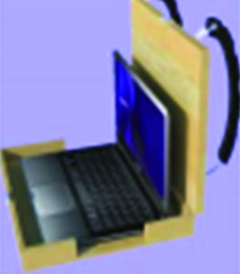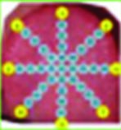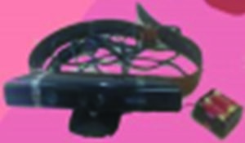

Tactile-visual

substitution

Backpack

Mobile Kinect

impaired people using either audio feedback or sensory substitution device or vibration. However, the system is not reliable when the intensity of light is heavy. The system is more costly and heavier to bear and only able to detect obstacles in a small range.

Stahlschmidt et al. [27], [28] introduced a technique to verify the presence of ascending and descending staircases or steps to assist visually impaired people. The system used Time-of-Flight (ToF) A camera that is fixed to a mobile device to capture an image and then produced depth data. The proposed algorithm, based on depth data, uses geometrical cues to detect ascending stairs in unknown environments from 3D data. The main component used in the proposed system is a Time-of-Flight camera with a rollator. A system is a fast approach for the detection of ascending staircases in organized point clouds and provide assistive information about the environment for the visually impaired people. However, it cannot detect pedestrians, spiral staircases. The descending staircase detection procedure is depicted in Figure 4.

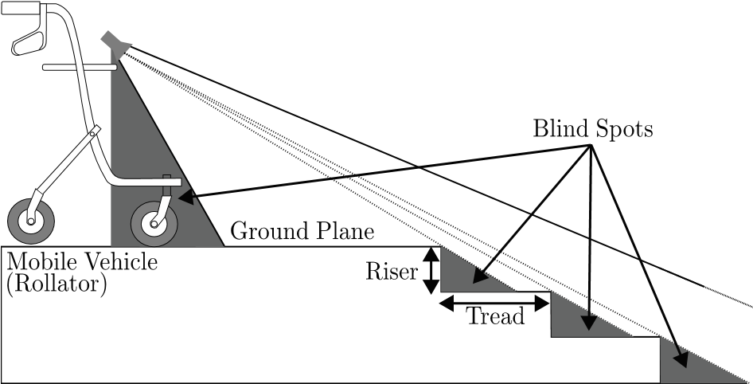

Figure 4: Descending staircase detection proposed in [22]

Lee et al. [29] developed a real-time staircase detection system in the context of a navigation aid for the visually impaired. The system uses a stereo camera to acquire data and implement a real-time Simultaneous Localization and Mapping (SLAM) which is an obstacle avoidance algorithm, and path planning algorithm. Both algorithms generate an appropriate cue and deliver to the tactile sensor. The approach used classifiers trained using Haar features and Adaboost learning. The main components used in the scheme are a stereo camera, four tactile feedback effectors. The proposed system is lightweight and will be effective for the blind people as the system will give notification to the individuals if there is a staircase or not in front of them. It drastically reduces the false.

alarm and provides more flexibility. However, the system may not perform well in the dark situations.

Table 1 summaries the above-described staircase detection systems considering the following criteria: which types of sensors the system used, accuracy, coverage area, cost, day/night conditions, which types of objects, the used algorithms, detection range and used technologies.

# Discussions

The paper discusses the system's usefulness indicated by the accuracy. Most of the systems achieved comparatively high accuracy.

From the Table 1, it can be shown that the system developed in [15] obtained higher accuracy as far we reviewed. Besides, the system is light weighted and low cost about $25. The vision-based system used the RGBD camera in common to extract staircase by using different algorithms from the captured image with great accuracy rate. The system introduced in [19] achieved an accuracy of 95.2 % with the resolution of 640x360 with the stairs. The accuracies obtained by the system [20] are around 97.61%, 97.56% and 96.67% for distance estimation, indoor and outdoor respectively. However, the system is heavily weighted and cannot differentiate between pedestrian and staircase rather detect them. A video processing-based system proposed in [21] appraised an accuracy of 96% (with staircase) although the system can’t detect any movement of other objects on the stairs. The system acquired an accuracy of 97.2% for stairs and 78.9% for crosswalk developed in [24] which is the highest for staircase detection among vision-based systems. The hybrid systems used both the camera and sensor to detect staircase to get more accurate results. The accuracy rate of 97% for upstairs and 89% for downstairs is obtained by the system developed in [26]. The systems developed in [27]-[28] achieved the accuracy of 95.51% for descending and 93.32% for descending stairs using the RANSAC algorithm. The system in [29] achieved the accuracy of 98.3% as it used both the SLAM and path planning algorithm for detection.

Almost all the reviewable systems are in high cost except [15]. Some of the systems worked in day light [19]-[24], [26], [29] and others in both day and night [15], [25], [27], [28]. Some systems [15]-[20], [22], [25]-[29] detect the static objects and others [21], [23], [24] detect both static and dynamic. The highest detection range about 7m covered by the system in [22].

From the above discussions, it can be noted that the highest accuracy of 99.83% is obtained by the system developed in [15] among all the system that we have reviewed. It may be argued that not a single system can fulfill the users demand correctly.

# Conclusion

The development of assistive devices for the visually impaired people has become very important to aid them in navigation. While navigating in the real world, these systems have quite high significance as the individuals require this kind of support. The reviewed systems have many pros and cons, but most of the systems obtained a very high accuracy rate while

Table 1

Summary of the staircase detection systems

|  |  |  |  |  |  |  |  |  |  |
| --- | --- | --- | --- | --- | --- | --- | --- | --- | --- |
| Authors | Type of sensors | Accuracy | Coverage | Cost | Day/Night | Classification Objects | Algorithms | Detection range | Used technologies |
| Razavi et al. [15] | Ultrasonic,  Gyroscope | Around 99.01% to 99.83% | Indoor/  Outdoor | Low | Day and Night | Static | N/A | About 5 feet | Ultrasonic technology |
| Romić et al. [19] | RGB-D Camera | 95.2% (For resolution 640x360 pixels) | Indoor | High | Day | Static | Canny Edge Detector, Morphological Closing Operator | 2 to 4 m | Computer vision technology |
| Khaliluzzaman et al. [20] | RGB-D Camera | Indoor-97.56%  Outdoor-96.67%  Distance Estimation-97.61% | Indoor/  Outdoor | High | Day | Static | Canny Edge Detector, Hough Transform, AdaBoost Learning, RANSAC | N/A | Computer vision technology |
| Romić et al. [21] | Camera | 96% (Staircase)  98% (Without Staircase) | Indoor/  Outdoor | High | Day | Static/  Dynamic | Canny Edge Detector,  Morphological Close Operator | 2 to 4 m | Computer vision technology |
| T. Schwarze and Z. Zhong [22] | RGB-D Scanners | Outdoor 94.4%(slope) and 96.7%(height) Indoor 98.3%(slope) and 96.3%(height) | Indoor/  Outdoor | High | Day | Static | RANSAC, OpenCV SGBM | Up to 7 m | Computer vision technology |
| S. Wang and Y. Tian al. [23] | RGB-D Camera | Stair – 97.2%  Crosswalk – 78.9% | Indoor/  Outdoor | High | Day | Static and dynamic | Hough Transform | N/A | Support vector machine (SVM) classifier |
| Shahrabadi et al. [24] | Stereo Camera | About 83% | Indoor/  Outdoor | High | Day | Static/  dynamic | Hough Transform, Canny Edge Detector | Around  5 m | Computer vision technology |
| Ponnada et al. [25] | Ultrasonic | Staircase – 88% | Outdoor/  Indoor | High | Day and night | Static | SURF | 0.02- 4 m | BGMM classifier and  Ultrasonic technology |
| Pham et al. [26] | Microsoft Kinect Sensor | Upstair-97%  Downstair  -89% | Indoor | High | Day | Static | RANSAC | 0.4-3.5  m | Voxel Grid Filter, Tongue Display Unit (TDU),  Kinect technology |
| Stahlschmidt et al. [27], [28] | ToF Camera Sensor | 93.32% (ascending)  95.51 %  (descending) | Indoor/ Outdoor | High | Day and Night | Static | RANSAC | 1.5-3 m  (ascending)  .8 - 6.5 m  (descending) | PMD technologies |
| Lee et al. [29] | Stereo Camera,  Tactile Sensor | Around 98.3 %. (true positive) | Indoor/ Outdoor | High | Day | Static | SLAM,  Path Planning, AdaBoost Learning | N/A | Computer vision technology |

**\*N/A: Not Appropriately defined**

detecting the stairs. The aforementioned systems worked only on the static and horizontal stairs, but none of the systems worked on the spiral stairs. While saying this most the systems are very heavy to bear with a high-quality processing device. The systems reviewed here have pretty importance on the future researches. Although several systems have been developed, there are a lot area of improvement for these devices to properly

properly help the visually impaired people.

##### References

1. R. R. A. Bourne, S.R. Flaxman, T. Braithwaite, M.V. Cicinelli, A.Das, J.B. Jonas, J. Keeffe, J.H. Kempen, J. Leasher, H. Limburg, and K. Naidoo, “Magnitude, temporal trends, and projections of the global prevalence of blindness and distance and near vision impairment: a systematic review and meta-analysis,” *Lancet Glob. Heal.*, vol. 5, no. 9, pp. e888–e897, Sep. 2017.
2. S. N. Abdulkader, A. Atia, M. M. Mostafa, “Brain computer interfacing: Applications and challenges,” in *Egyptian Informatics Journal*, vol. 16, no. 2, pp. 213-230, July 2015.
3. M. M. Islam and M. S. Sadi, “ Path Hole Detection to Assist the Visually Impaired People in Navigation,” in *Proc. 4th* *International Conference on Electrical Engineering and Information & Communication Technology*, Dhaka, in press, 2018.
4. M. M. Kamal, A. I. Bayazid, M. S. Sadi, M. M. Islam and N. Hasan, "Towards developing walking assistants for the visually impaired people," in *Proc. IEEE Region 10 Humanitarian Technology Conference (R10-HTC),* Dhaka, pp. 238-241, 2017.
5. M. S. Sadi, S. Mahmud, M. M. Kamal and A. I. Bayazid, “ Automated walk-in assistant for the blinds,” in *Proc. International Conference on Electrical Engineering and Information & Communication Technology*, Dhaka, pp. 1-4, 2014.
6. A. Ciobanu, A. Morar, F. Moldoveanu, L. Petrescu, O. Ferche and A. Moldoveanu, "Real-Time Indoor Staircase Detection on Mobile Devices," in *Proc. 21st International Conference on Control Systems and Computer Science (CSCS)*, Bucharest, pp. 287-293, 2017.
7. I.A. Syed, P. Shine,K. D. Naidu, B. Sharma, S. Singh, D. Deodhare, “Autonomous Staircase Navigation System for Multi-floor Tasks,” in *Proc. 2nd International Conference on Computer Vision & Image Processing*, pp. 235-247, Singapore, 2018.
8. D. Aguilera-Castro, M. Neira-Cárcamo, C. Aguilera-Carrasco and L. Vera-Quiroga, "Stairs recognition using stereo vision-based algorithm in NAO robot," in *Proc. CHILEAN Conference on Electrical, Electronics Engineering, Information and Communication Technologies (CHILECON)*, Pucon, pp. 1-6, 2017.
9. A. Sinha, P. Papadakis and M. R. Elara, "A staircase detection method for 3D point clouds," in *Proc. 13th International Conference on Control Automation Robotics & Vision (ICARCV)*, Singapore, pp. 652-656, 2014.
10. R. Munoz, Xuejian Rong and Y. Tian, "Depth-aware indoor staircase detection and recognition for the visually impaired," in *Proc. IEEE International Conference on Multimedia & Expo Workshops (ICMEW)*, Seattle, WA, pp. 1-6, 2016.
11. J. A. Hesch, G. L. Mariottini and S. I. Roumeliotis, "Descending-stair detection, approach, and traversal with an autonomous tracked vehicle," in *Proc. IEEE/RSJ International Conference on Intelligent Robots and Systems*, Taipei, pp. 5525-5531, 2010.
12. M. Khaliluzzaman, and K. Deb, “Stairways detection based on approach evaluation and vertical vanishing point,” *International Journal of Computational Vision and Robotics*, vol. *8*, no. 2, pp.168-189, Aug. 2018.
13. S. Cloix, G. Bologna, V. Weiss, T. Pun, and D. Hasler, “ Low-power depth-based descending stair detection for smart assistive devices,” *EURASIP Journal on Image and Video Processing*, vol. 2016, no. 1, pp. 33, Oct. 2016.
14. A. Perez-Yus, D. Gutierrez-Gomez, G. Lopez-Nicolas, and J. J. Guerrero, “Stairs detection with odometry-aided traversal from a wearable RGB-D camera,” *Comput. Vis. Image Underst.,* vol. 154, pp. 192–205, Jan. 2017.
15. J. Razavi and T. Shinta, "A novel method of detecting stairs for the blind," in *Proc.* IEEE Conference on Wireless Sensors (ICWiSe), Miri, pp. 1-5, 2017.
16. X. Zhao, W. Chen, X. Yan, J. Wang and X. Wu, "Real-Time Stairs Geometric Parameters Estimation for Lower Limb Rehabilitation Exoskeleton," *2018 Chinese Control And Decision Conference (CCDC)*, Shenyang,, pp. 5018-5023, 2018.
17. X. Huang and Z. Tang, "Staircase Detection Algorithm Based on Projection-Histogram," *2018 2nd IEEE Advanced Information Management,Communicates,Electronic and Automation Control Conference (IMCEC)*, Xi'an, China, pp. 1130-1133, 2018.
18. M. Leo, G. Medioni, M. Trivedi, T. Kanade, and G. Farinella, “Computer vision for assistive technologies,” *Computer Vision and Image Understanding*, vol.154, pp.1–15, Jan. 2017.
19. K. Romić, I. Galić and H. Leventić, "Influence of the input image resolution on the staircase detection," in Proc. International Symposium ELMAR, Zadar, pp. 177-180, 2016.
20. M. Khaliluzzaman, K. Deb and K. Jo, "Stairways detection and distance estimation approach based on three connected point and triangular similarity," in Proc. 9th International Conference on Human System Interactions (HSI), Portsmouth, pp. 330-336, 2016.
21. K. Romić, I. Galić and T. Galba, "Technology assisting the blind — Video processing based staircase detection," in Proc. 57th International Symposium ELMAR (ELMAR), Zadar, pp. 221-224, 2015.
22. T. Schwarze and Z. Zhong, "Stair detection and tracking from egocentric stereo vision," in Proc. IEEE International Conference on Image Processing (ICIP), Quebec City, QC, pp. 2690-2694, 2015.
23. S. Shahrabadi, J. M. Rodrigues, and J. H. Du Buf, “Detection of indoor and outdoor stairs,” in *Pattern Recognition and Image Analysis*, Springer, pp. 847–854, 2013.
24. S. Wang and Y. Tian, "Detecting stairs and pedestrian crosswalks for the blind by RGBD camera," in Proc. IEEE International Conference on Bioinformatics and Biomedicine Workshops, Philadelphia, PA, pp. 732-739, 2012.
25. S. Ponnada, S. Yarramalle and M. R. T. V., "A Hybrid Approach for Identification of Manhole and Staircase to Assist Visually Challenged," in IEEE Access, vol. 6, pp. 41013-41022, Jul. 2018.
26. H.-H. Pham, T.-L. Le, and N. Vuillerme, “Real-time obstacle detection system in indoor environment for the visually impaired using microsoft kinect sensor, *Journal of Sensors*, vol. 2016, pp. 13, 2016.
27. C. Stahlschmidt, A. Gavriilidis and A. Kummert, "Classification of ascending steps and stairs using Time-of-Flight sensor data," in Proc. IEEE 9th International Workshop on Multidimensional (nD) Systems (nDS), Vila Real, pp. 1-6, 2015.
28. C. Stahlschmidt, S. von Camen, A. Gavriilidis and A. Kummert, "Descending step classification using time-of-flight sensor data," in Proc. IEEE Intelligent Vehicles Symposium (IV), Seoul, pp. 362-367, 2015.
29. Y. H. Lee, T. Leung and G. Medioni, "Real-time staircase detection from a wearable stereo system," in Proc. 21st International Conference on Pattern Recognition (ICPR2012), Tsukuba, pp. 3770-3773, 2012.